

**DEPARTMENT OF MATHEMATICS**

**PROJECT RECORD**

**ON**

**UNEARTHING THE ENVIRONMENTAL IMPACT OF HUMAN ACTIVITY: A GLOBAL CO2 EMISSION ANALYSIS**

* **DATA ANALYTICS WITH TABLEAU**

**TAMILNADU SKILL DEVELOPMENT CORPORATION, GOVERNMENT OF TAMILNADU,**

**NAAN MUDHALVAN PROGRAM**

**Submitted**

**By**

1. **A.KASTHURI (222006456)**
2. **K.MANGALA DEEPA (222006459)**
3. **I.DHANUPRIYA (222006449)**
4. **S.SASIKALA (222006469)**

**(III B.Sc MATHEMATICS)**

**CERTIFICATE**

THIS IS TO CERTIFY THAT THE PROJECT IS TITLED **UNEARTHING THE ENVIRONMENTAL IMPACT OF HUMAN ACTIVITY: A GLOBAL CO2 EMISSION ANALYSIS- DATA ANALYTICS WITH TABLEAU.**

THIS PROJECT IS SUBMITTED BY A.KASTHURI (222006456), K.MANAGALADEEPA (222006459), I.DHANUPRIYA (222006449), S.SASIKALA (222006459) OF III B.SC MATHEMATICS, Dr.MGR JANAKI COLLEGE OF ARTS AND SCIENCE FOR WOMEN, CHENNAI IN FULFILMENT OF THE REQUIREMENTS FOR **TAMIL NADU SKILL DEVELOPMENT CORPORATION, GOVERNMENT OF TAMILNADU,NAAN MUDHALVAN PROGRAM**. THIS PROJECT WAS AN AUTHENTIC WORK DONE BY HIM UNDER MY SUPERVISION AND GUIDANCE.

 

**PROJECT GUIDE HOD**

**TABLE OF CONTENTS**

| **S.NO** | **CONTENTS** | **PAGE NO** |
| --- | --- | --- |
| **1** | **INTRODUCTION** | 4 |
|  | 1.1 OVERVIEW | 4 |
|  | 1.2 PURPOSE | 4 |
| **2** | **PROBLEM DEFINITION & DESIGN THINKING** | 5 |
|  | 2.1 EMPATHY MAP | 5 |
|  | 2.2 IDEATION & BRAINSTORMING MAP | 6 |
| **3** | **RESULT** | 7 |
| **4** | **ADVANTAGES & DISADVANTAGES** | 9 |
|  | 4.1 CARBON CAPTURE & STORAGE(CCS) | 9 |
|  | 4.2 ADVANTAGES OF CCS | 9 |
|  | 4.3 DISADVANTAGES OF CCS | 9 |
| **5** | **APPLICATIONS** | 10 |
| **6** | **CONCLUSION** | 11 |
| **7** | **FUTURE SCOPE** | 12 |
| **8** | **VIDEO LINK** | 13 |

**UNEARTHING THE ENVIRONMENTAL IMPACT OF HUMAN ACTIVITY: A GLOBAL CO2 EMISSION ANALYSIS**

1. **INTRODUCTION**

**1.1 OVERVIEW**

The global CO2 emissions and energy demand numbers are based on the IEA’s detailed region-by-region and fuel-by-fuel analysis, drawing on the latest official national data and publicly available energy, economic and weather data. Combined with the methane emissions estimates published by the IEA and estimates of nitrous oxide and flaring related CO2 emissions, this new analysis shows that overall greenhouse gas emissions from energy rose to their highest ever level in 2021.

**1.2 PURPOSE**

The carbon in CO2 can be used to produce fuels that are in use today, including methane, methanol, gasoline and aviation fuels.CO2-derived fuels are particularly interesting for applications where the use of other low-carbon energy carriers, such as electricity or hydrogen, is extremely challenging, such as in aviation. Several firms have already built demonstration and pilot plants producing methane and methanol from CO2 and hydrogen, together using hundreds to thousands of tonnes of CO2 per year. Other chemical and biological conversion pathways to produce CO2-derived fuels are in the early research or demonstration stages.

1. **PROBLEM DEFINITION & DESIGN THINKING**

**2.1 EMPATHY MAP**

An empathy map is a collaborative tool teams can use to gain a deeper insight into their customers. Much like a user persona, an empathy map can represent a group of users, such as a customer segment. The empathy map was originally created by Dave Gray and has gained much popularity within the agile communityAssemble your team and have them bring any personas, data, or insights about the target of your empathy map. Print out or sketch the empathy map template on a large piece of paper or whiteboard. Hand each team member sticky notes and a marker. Each person should write down their thoughts on stickies. Ideally everyone would add at least one sticky to every section. You might ask questions, such as:

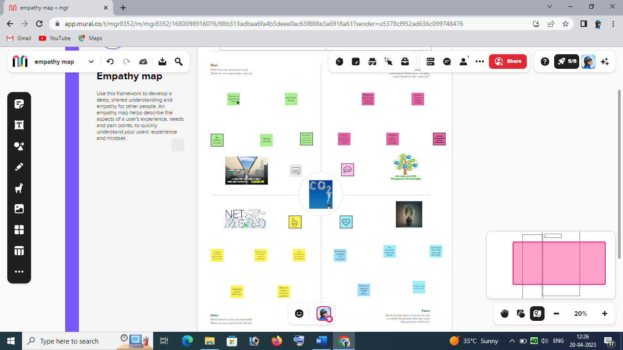

**2.2 IDEATION & BRAINSTORMING MAP**

Brainstorming is a method of generating ideas and sharing knowledge to solve a particular commercial or technical problem, in which participants are encouraged to think without interruption. Brainstorming is a group activity where each participant shares their ideas as soon as they come to mind. At the conclusion of the session, ideas are categorised and ranked for follow-on action.When planning a brainstorming session it is important to define clearly the topic to be addressed. A topic which is too specific can constrict thinking, while an ill-defined topic will not generate enough directly applicable ideas. The composition of the brainstorming group is important too. It should include people linked directly with the subject as well as those who can contribute novel and unexpected ideas. It can comprise staff from inside or outside the organisation.

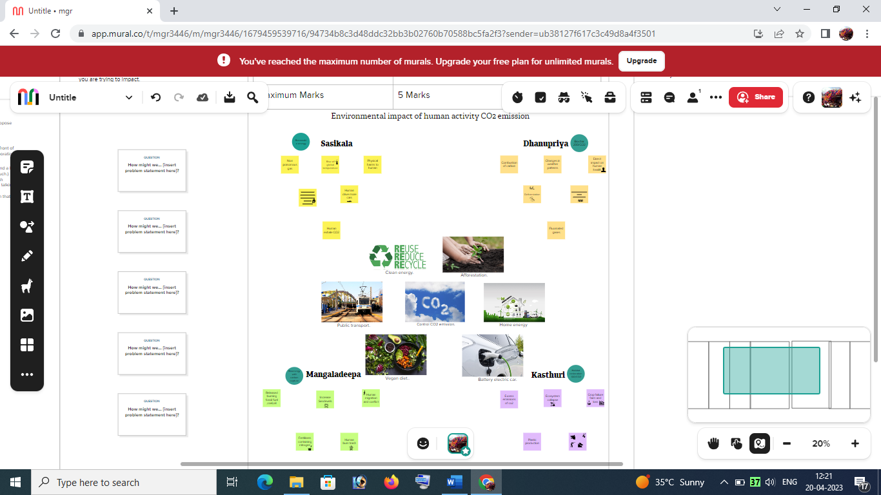

1. **RESULT**

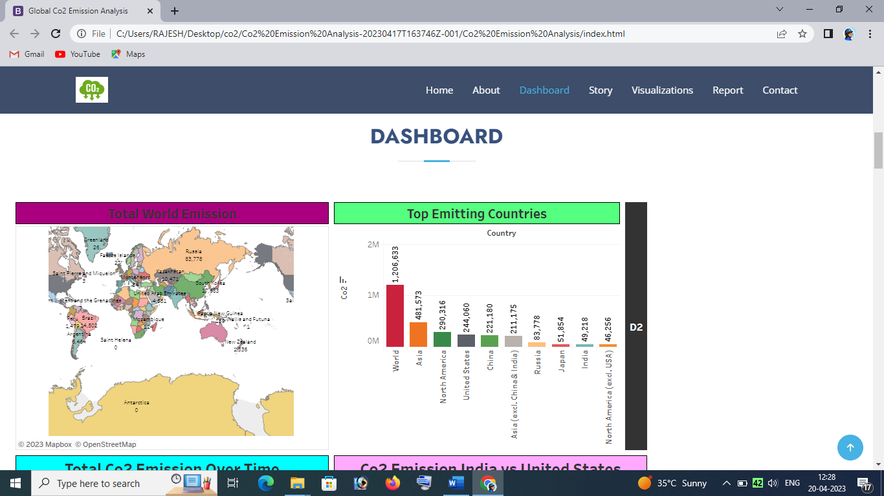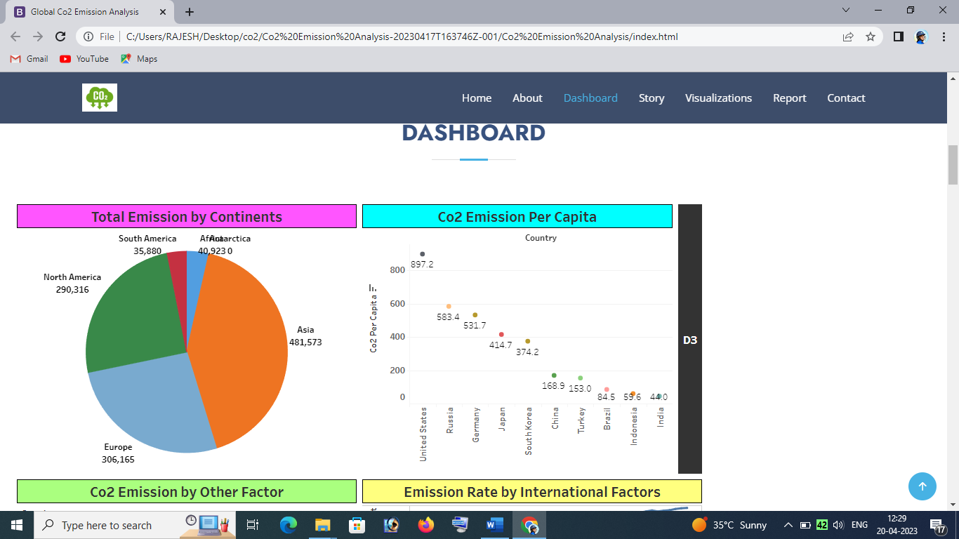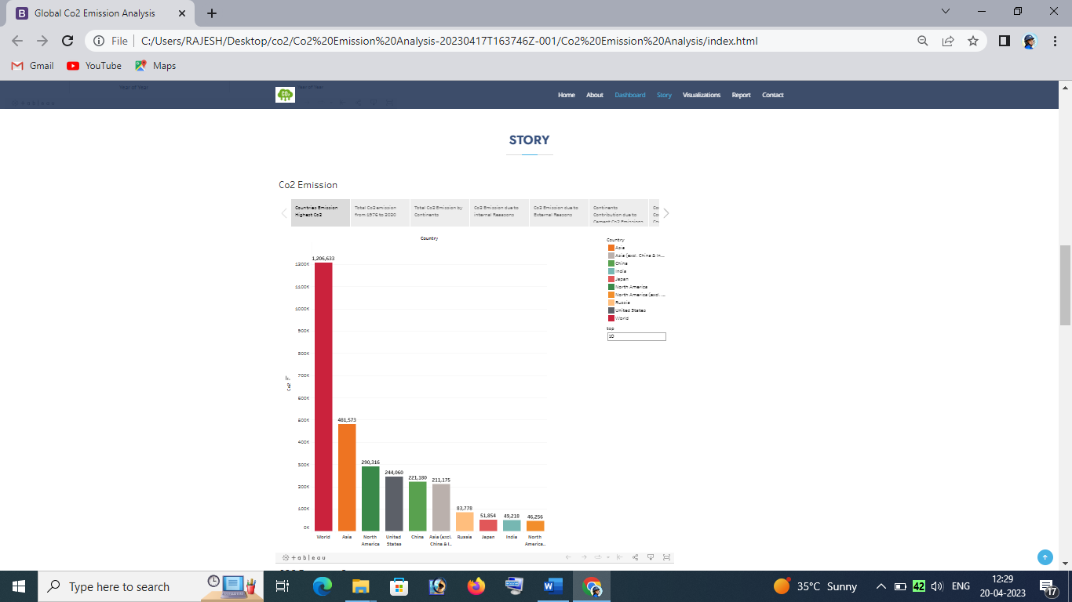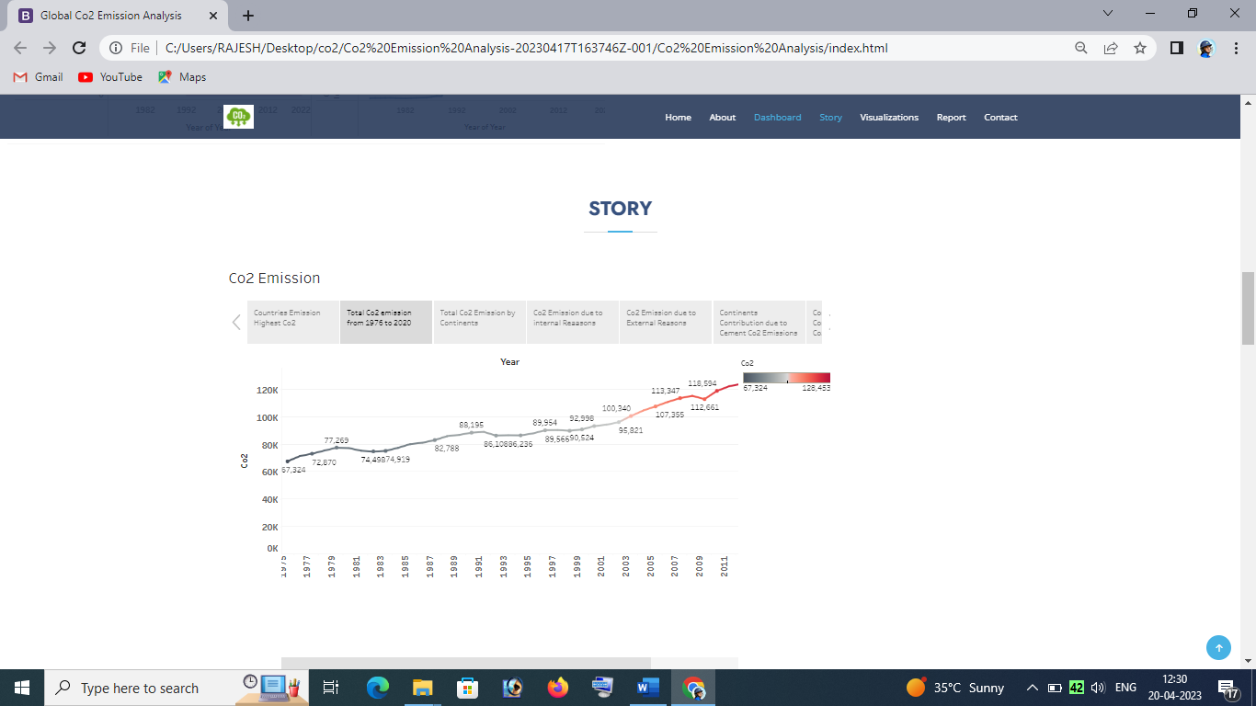

1. **ADVANTAGES & DISADVANTAGES**

**4.1. Carbon Capture and Storage (CCS) :**

Carbon capture and storage (CCS) is the process of removing CO2 from industrial processes such as power plants that burn fossil fuels. The CO2 is then transported and placed in long-term storage, typically in underground geologic formations. The CO2 that is removed can either be taken out before combustion occurs or after.

**4.2. Advantages of CCS:**

According to the Grantham Institute at the London School of Economics, CCS is currently the only carbon capture technology that can reduce emissions from industrial plants, and it has several advantages over other types of carbon removal technology.

**4.3. Disadvantages of CCS:**

Even with the advantages of using CCS to help reduce the amount of CO2 that is emitted into the atmosphere, there are several issues related to the implementation of the technology that still need to be worked out.

1. **APPLICATIONS**

* Now, about the actual inputs. CarbonWatch asks users for their average units of freshwater billed per month in kilolitres. That means you need to have your utility bill on hand. There are no comparative guidelines on how you may be able to gauge your consumption based on how many buckets of water you use per month.
* The reason this is important is because not everyone rents an entire house, especially students or bachelors. They usually have a single room or only a part of the house for use. Hence, they may not necessarily have access to the utility bill. And, even if they do have access to it, the entire consumption of water does not rest on their shoulders.
* The same applies to the consumption of electricity. It would be easier if the app asked users what kind of lights they use (LED, CFL or other ordinary bulbs), how many are in the room or house, and how many hours, on average, they are switched on for.
* And, while it is useful to ask whether or not a user is segregating their waste, the app doesn’t ask for an estimate of how much waste is being produced in the first place.
* A score of fairly high. And, the only basis of comparison is worldwide averages. In our case, it was much higher than India’s average of 1.81 or even the global average of 4.74 tonnes of carbon dioxide emissions.

1. **CONCLUSION**

* The Positive Externalities of Carbon Dioxide: Estimating the Monetary Benefits of Rising Atmospheric CO2 Concentrations on Global Food Production
* It is clear from the material presented in this report that the modern rise in the air's CO2 content is providing a tremendous economic benefit to global crop production. As Sylvan Wittwer, the father of agricultural research on this topic, so eloquently put it nearly two decades ago:
* "The rising level of atmospheric CO2 could be the one global natural resource that is progressively increasing food production and total biological output, in a world of otherwise diminishing natural resources of land, water, energy, minerals, and fertiliser. It is a means of inadvertently increasing the productivity of farming systems and other photosynthetically active ecosystems. The effects know no boundaries and both developing and developed countries are, and will be, sharing equally," for "the rising level of atmospheric CO2 is a universally free premium, gaining in magnitude with time, on which we all can reckon for the foreseeable future" (Wittwer, 1995).
* The relationship described above by Wittwer is illustrated below in Figure 8, where data pertaining to atmospheric CO2 emissions, food production, and human population are plotted. Standardised to a value of unity in 1961, each of these datasets has experienced rapid and interlinked growth over the past five decades. Rising global population has led to rising CO2 emissions and rising CO2 emissions have benefited food production.
* The very real positive externality of inadvertent atmospheric CO2 enrichment must be considered in all studies examining the SCC; and its observationally-deduced effects must be given premier weighting over the speculative negative externalities presumed to occur in computer model projections of global warming. Until that time, little if any weight should be placed on current SCC calculations.

1. **FUTURE SCOPE**

* Future changes are expected to include a warmer atmosphere, a warmer and more acidic ocean, higher sea levels, and larger changes in precipitation patterns. The extent of future climate change depends on what we do now to reduce greenhouse gas emissions.
* EY continues to reduce its greenhouse gas (GHG) emissions, and is carbon negative for the second year, meaning we offset and remove more carbon than we emit.
* Our challenge going forward is to decouple business growth from emissions growth, while supporting clients and maintaining our distinctive global culture.
* We are investing in services, technology and products to help clients decarbonize their businesses and accelerate the transition to a low-carbon economy.

1. **VIDEO LINK**

Explanation Video LINK : <https://drive.google.com/file/d/1buUdWV2UYh1uMqfZDhjcEZL8idFzm-8o/view?usp=drivesdk>